Waterfall Model

The waterfall Model first introduced by Dr. Winston Royce in 1970 documents a process that can be used to plan out software development. The waterfall model takes the most logical steps is the software development cycle and puts them in cascading order. The waterfall model starts with the task that must be completed first and then the task that must be completed next directly after eventually cascading down to the last task to be completed. The model begins with the requirement stage where the requirement of the application are analysed in a software requirement specification (SRS). After the requirements are established the design stage outlines details such as programming language, data storage method. Next the actual code for the application is written and is then systematically tested through techniques such as test tables or beta testers. Once the application is ready for deployment maintenance must be performed to ensure that it keeps running efficiently and without any bugs and up to date.

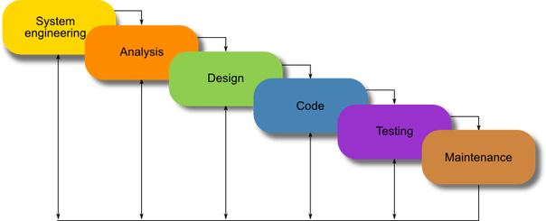I have chosen the waterfall model to develop my application “Any Kitchen” for 4 main reasons. Firstly, it matches my ideology of finishing a task before moving on and not coming back to tasks later unnecessarily as I find a simple linear development process less confusing and more efficient then more versatile processes. Secondly, I find the linear process allows the better establishment of milestones creating a rewarding sense of completion as well as providing motivation to complete certain aspects of the process. Lastly, I prefer forced organization structures that forces me to be disciplined in the design and building of my application by not allowing me to deviate to other tasks, allowing me to focus on individual components.